
Psychological impact of YouTube Recommendation

Date : 1st April 2020 vikash vishwakarma ^{[1]} Sanjay Kumar^{[2]}

- Department of computer science and engineering , Lovely Professional University, Punjab 144411, India;
- vikashsharma190@gmail.com,sanjayksingh.012@gmail.com (S.K.S.)
- Real base problem conducted by survey of 100 people

Abstract:
The purpose of this study ar (1) to research the influence of youtube Recommendation on prosocial behavior, (2) to analyze the influence of the quantity of Youtube youngsters social media show frequency on babyhood prosocial behavior, (3) to understand the impact of the period of Youtube youngsters social media shows on babyhood prosocial behavior, and (4) to research the influence of attention on Youtube social media shows that ar watched on babyhood prosocial behavior. The analysis methodology uses a quantitative approach with non-experimental style and therefore the knowledge analyzed is as ex post facto variable quantity. The sampling technique during this study uses total sampling techniques or census techniques in order that the quantity of samples were a hundred individuals of various people. knowledge analysis used multivariate analysis. supported the results of the study, the youtube provides a positive impact on childhood prosocial behavior. The positive impact of youtube on individuals among totally different people, in frequency, period and a focus facet is analysis by conducting a survey asking question releted to youtube that analysis to urge the impact on this psychological

Introduction:

The impact of social media shows incorporates a positive and negative impact on children's development a positive impact on children's mindsets, specifically serving to kids to control their speed of play,cultivat-ing methods within the game, and serving to to enhance the flexibility of the child's cerebral hemisphere. whereas the negative impact of social media is that it will cut back the active power of kids and therefore the ability of kids to move with others, therefore giving rise to individualist attitudes (Khairuni 2016).
The development of prosocial behavior has a very important role within the lives of kids. kids will learn behavior which will be accepted by their surroundings, play roles in teams, and may adapt to their surroundings. the consequences of media exposure rely on the content of the media. it had been explained that media with delinquent content will enhance delinquent behavior and cut back prosocial behavior, whereas media containing prosocial is assumed to extend prosocial and cut back delinquent (Nuswantari& Astuti,2015).Mandey, Koagouw, & Senduk(2015), Frisnawati (2012) and Greitemeyer(2015) disclosed the frequency of looking at media shows will influence prosocial attitudes that embrace sympathetic, comparative aspects, providing help and help, giving donations, temperament to sacrifice, like to save others, and volunteering in doing humanitarian activities.

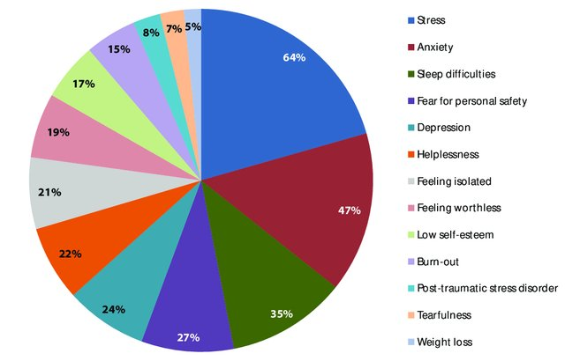

Fig 1: Element of impact in human life

During survey this are the point which i have taken into consideration because those who watch youtube from last 3-5 year are facing some kind of psychological impact on thier life .How to find wheather a person is getting impacted due to watching videos . It’s very hard to find because it requred introinspection where we need to analysis what we are doing , what its important , how many hour we should watch how to use it .If a person got involve in its the we can find it effect by asking some question . In this research i haveconducted a survey of 100 people of different age group and ask some question base on that i analysis wearther theiris consequence effect on them or not .

Analysis to get the impact on this psychological

Age group
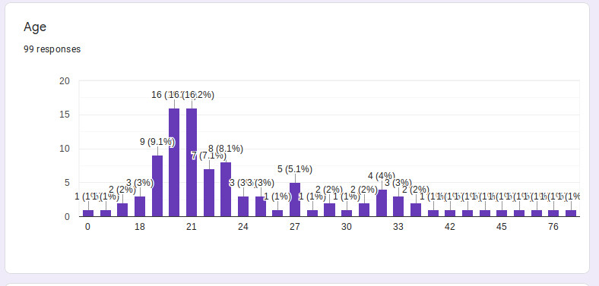
What is Psychology
Psychology is that the science of behavior and mind. scientific discipline includes the study of aware and unconscious phenomena, further as feeling and thought. it's a tutorial discipline of Brobdingnagian scopepsychological factors associated with social media are: depression, anxiety, attachment, self-identity, and therefore the ought to belong.
What is Recommendation
Recommender Systems ar among the foremost common styles of Machine Learning that users can encounter, whether or not they’re alert to it or not. It powers curated timelines on Facebook and Twitter, and “suggested videos” on YouTube
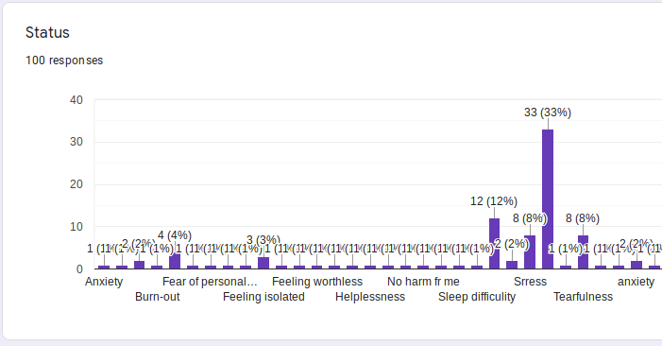

Fig 2: Current Problem face by People
Among 100 people 33% of them are in Stress ,12% are in Sleep difficulity 8% Tearfulness and 8% anxiety.
Higest number of them are in Stress
Health problems caused or exacerbated by stress include:
Pain of any kind Sleep problems
Autoimmune diseases Digestive problems
Skin conditions, such as eczema Heart disease
Weight problems Reproductive issues
Thinking and memory problems Depression and anxiety
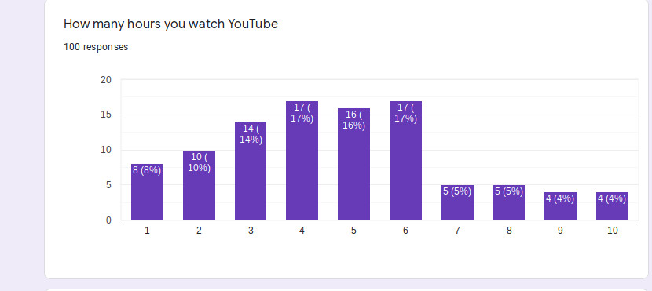

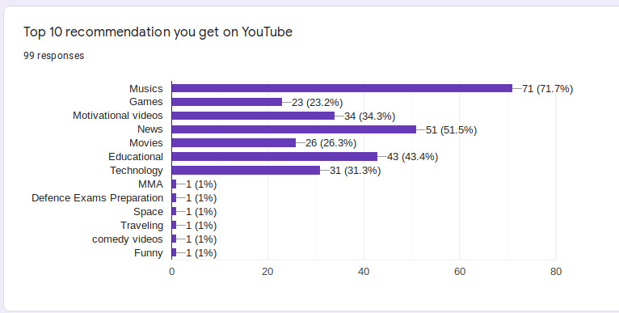
Mostly individuals watch youtube over three hours on a daily basis regarding eighty two individuals watch additional tha three time unit.Reason why we tend to pay longer is owing to new videos uploded daily and that we get recommendationand notification . Youtube prefere major development in those Algorithms that being individuals andget additional read . after I raise what reasonably recommendation user get i found seventy one says musics , 51% News,43%educattional videos .This ar those content which magnetize individuals to waste longer and sure them for long .

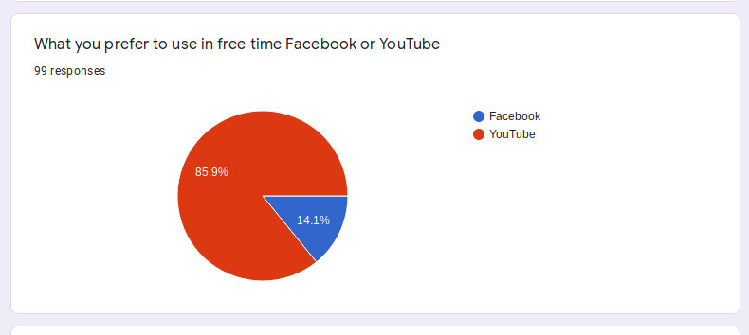

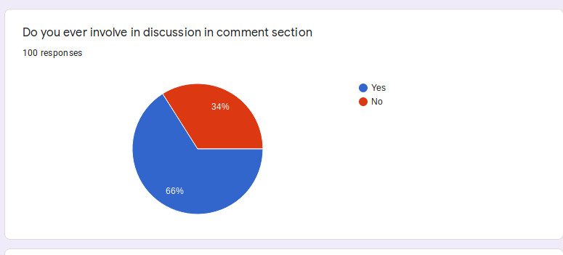
Comment Section where user provide their view or opnion .opinion can be toward or against but it doesn’t means you start fighting and demolished other view .In most of New channel people stating fighting
within communtity . Most of them harashed other people or use valgure comment which make people Depression and anxiety which is part of stress . About 66% people
involve in discussion 34% not

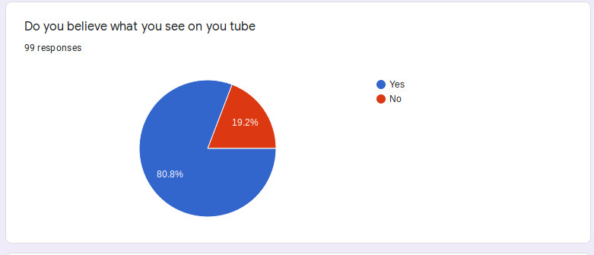
81% people blindly believe what they see on youtube . Since concent varification is one of the important part in this world because of fake and valgure videos .People don’t varified what they seen and those how make vedios their credentials is also hidden.
Because of this their is lot of useless things which are not scientifically proven.when we take about fake news
facebook,youtube play an important role is spreading because of widely use

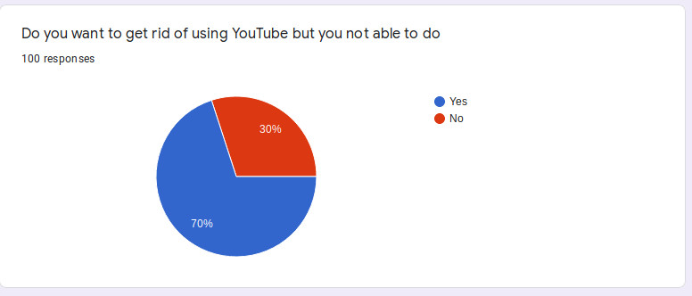
What forcing people to stick to youtube is it content or quality .In order to spread data to every user base on previous view and like youtube use Algorithm
this recommendation algo
provide them new content daily because of this people get attach with it
70% people say that they want to get rid of using youtube for long periode of time but not able to

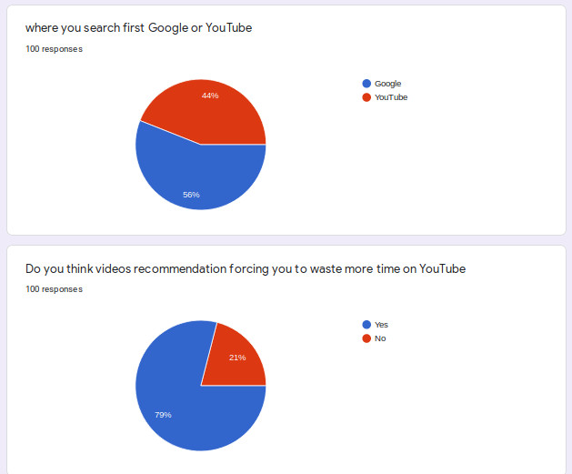
Content valaditaion is one of important feature in google than youtube .
Google show result from mostly authorised website which is maintained by many people not by single when i ask people where they use to search first when they want some information 56% say they use youtube while 44% use google inorder to get information

Wasting time is one of the important part which cause stress .79% people believe that geting new videos and
notification is cause of waste of time

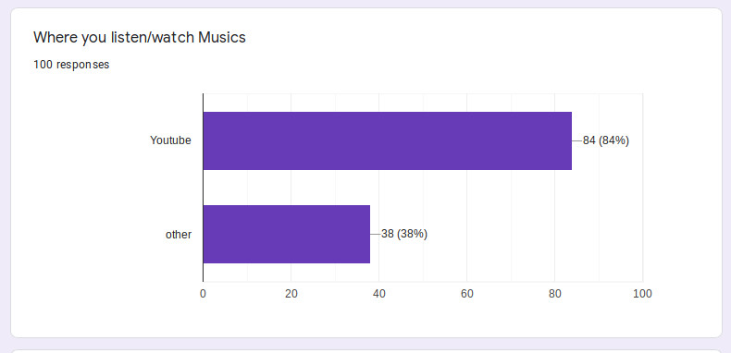

As we have seen that Musics is mostly used on youtube .
84% people listen musics on youtube while many of them use even they did’t see videos just for mp3.we have other platform which can provide mp3 where you can turn off phone also but due to strongly attachment they prefer youtube even for mp3

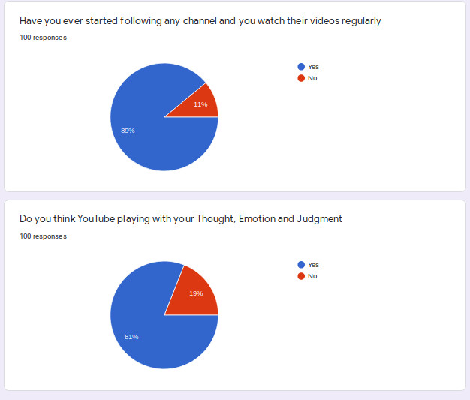

When we are take about Psychology impact we must consider those this which change people view , thought
Emotion and Judgement . 81% people say youtube is one of them
You don’t notice how much it’s affecting you, even as it takes a heavy toll. That’s why it’s important to be aware of the common warning signs and symptoms of Psychology overload.

Cognitive symptoms: Emotional symptoms:

Memory problems Depression or general unhappiness
Inability to concentrate Anxiety and agitation
Poor judgment Moodiness, irritability, or anger
Seeing only the negative Feeling overwhelmed
Constant worrying Loneliness and isolation

Physical symptoms: Behavioral symptoms:

Aches and pains Eating more or less
Nausea, dizziness Sleeping too much or too little
Frequent colds or flu Using alcohol, cigarettes,to relax

S No. | Question | Percentage
1 | Top 10 recommendation you get on YouTube | Musics 71%
2 | What you prefer to use in free time Facebook or YouTube | Youtube 86%
3 | Do you ever involve in discussion in comment section | 66%
4 | Do you believe what you see on you tube | 81%
5 | Do you want to get rid of using YouTube but you not able to do | 70%
6 | Where you listen/watch Musics | Musics 84%
7 | where you search first Google or YouTube | 56%
8 | Do you think videos recommendation forcing you to waste more time on YouTube | 79%
9 | Have you ever started following any channel and you watch their videos regularly | 89%
10 | Do you think YouTube playing with your Thought, Emotion and Judgment | 81%

Conculsion:

The technology advances, the quantity of social media users is additionally increasing each year. As a result, positive and negative impacts caused social media is additionally a bearing on the user. one in all the consequences of the utilization of social media is AN influence on prosocial behavior that happens among teenagers by mistreatment info technology, particularly the utilization of social media facebook. the aim of this study was to see what proportion influence the utilization of social media facebook toward prosocial behavior of teenagers supported the analysis and discussion distributed on the influence of Youtube youngsters
social media shows on prosocial behavior, it are often complete that there ar positive and important influences of youtube youngsters social media shows on babyhood prosocial behavior, there's a positive and important influence on youtube youngsters social frequency on age prosocialbehavior early, there isa positive and important influence on youtube youngsters 'social media period on babyhood prosocial behaviorand a positive and important influence on youtube kids' social media attention to babyhood prosocial behavior
From the on top of Analysis i found principally individuals either old-time less<17 or >17 or older people get wedged the question that I actually have taken into thought i found principally five hundredth belive their ar wedged directly or indirectly

Refference :

Arikunto, S. (2011). Prosedur Penelitian Suatu Pendekatan Praktis. Jakarta: Rineka Cipta Asmaya, F. & Rumyeni (2015). Pengaruh
Penggunaan Media Sosial
https://jom.unri.ac.id/index.php/JOMFSIP/article/view/7543

Dayakisni, T.& Hudainah.(2006).
Psikologi Sosial. Malang: UMM Press
Retrieved from
http://ummpress.umm.ac.id/katalog/detail/psikologisosial.html

http://ummpress.umm.ac.id/katalog/detail/psikologisosial.html

https://www.helpguide.org/articles/stress/stress-symptoms-signs-and-causes.htm

https://journal.unnes.ac.id/sju/index.php/jpe/article/view/27730/12176

https://pixlr.com

PLAGIARISM

